**Conditional Handling**

It is also known as Decision handling. It is used to perform different actions based on whether a specific condition or set of conditions is true or false.

**Types of Conditional Statements:**

**If Statement**

**Syntax:** if condition:

It executes a block of code only if the specified condition evaluates to true.

**Example**:

a=int(input())  
if(a>10):  
 print("it is a positive number")

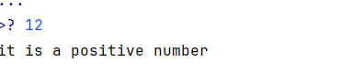

**If else:**

Provides an alternative block of code to execute when the condition is false.

**Syntax:**

**if condition:**

# Code to execute if the condition is true

**else:**

# Code to execute if the condition is false

*#if else statement*a=10  
b=20  
if(a>b):  
 print("a is greater")  
else:  
 print("b is greater")

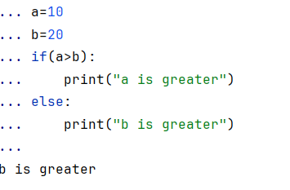

**If-Elif-Else Statement**

It is used for multiple conditions. The program evaluates each condition in order until it finds one that is true.

**Syntax:**

if condition1:

# Code to execute if condition1 is true

**elif condition2:**

# Code to execute if condition2 is true

else:

# Code to execute if all conditions are false

Example:

*#if elif else statement*signal=str(input())  
if(signal=="red"):  
 print("stop")  
elif(signal=="green"):  
 print("go")  
elif(signal=="yellow"):  
 print("get ready")  
else:  
 print("invalid signal")

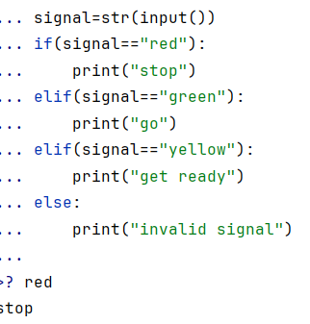

**Nested If Statements**

**Syntax:**

If condition:

If condition:

Statements

Else:

Statements

else:

if condition:

statements

else:

statements

An if statement placed inside another if statement to check multiple levels of conditions.

Example:

*#nested if statements*a=21  
b=43  
c=12  
if(a>b):  
 if(a>c):  
 print("a is greater")  
 else:  
 print("c is greater")  
else:  
 if(b>c):  
 print("b is greater")  
 else:  
 print("c is greater")

